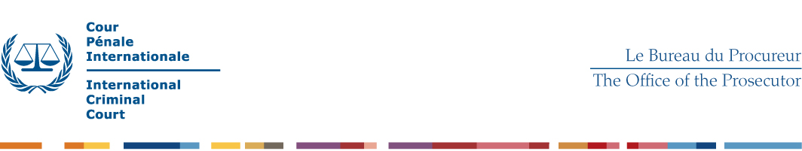
TERMS OF REFERENCE – ANALYST

- Operational Context

The Office of the Prosecutor (“OTP”) needs systematic analysis of relevant information and evidence as an essential part of its investigations on alleged ICC crimes. Professional analysis of multiple sources, incidents and patterns of crime is required to develop investigative hypotheses, to collect relevant evidence, and ultimately to identify those persons who appear to be most responsible. The ICC Judges have stressed in their decisions the critical importance of systematic and objective analysis of the facts to decide on the alleged crimes and responsibilities, under arts. 5 to 8 (genocide, crimes against humanity and war crimes) and art. 25 or 28 of the ICC Statute (Individual Criminal Responsibility, or Responsibility of Commanders and Other Superiors).

Analysts operate within the OTP Unified Teams, under the ICC normative framework, as well as the OTP internal regulations and analytical standards. The OTP investigates alleged crimes impartially in order to establish the truth, considering “incriminating and exonerating circumstances equally” (art. 54-1-a ICC Statute).

The OTP needs to rely for its investigations on cooperation from multiple state authorities, international organisations and civil society. Staff is expected to cooperate effectively with partners, with due respect to their mandates, professional and cultural context. The OTP Unified Teams are highly diverse and staff need to operate with due respect and appreciation for diversity, including professional, gender, culture, and linguistic considerations.

- Tasks

Analysis of crime incidents and patterns – To analyse the available information and evidence in relation to alleged crime incidents and patterns, including estimates and identification of victims and their profile, locations and patterns of geographical distribution, time and chronological distribution, and identification of perpetrators and their modus operanda.

Analysis of organisations and networks – To analyse the available information and evidence in order to identify the relevant systems of command, control and communications utilised in the commission of the alleged crimes, including identification of key members, units and commanders, communications, logistics and finances.

Dissemination – To convey the relevant analysis through analytical products sourced against specific items of information or evidence, including reports, relational charts, databases, and maps. Analytical products shall comply with the OTP analytical standards for report drafting, sourcing, critical thinking, source evaluation and accuracy.

Evidence collection – To assist in the collection of relevant evidence, including identification and exploitation of archives, communication records, interviews of insiders and experts, and open sources. Identification of relevant potential sources of any kind. Participation in field missions as required. Collection of internet open sources with appropriate security and forensic standards.

Team work – To participate in the work of the Unified Teams, including: cooperation with fellow analysts, investigators, lawyers and other colleagues; advise to team leadership on investigative strategies and evidentiary opportunities; participation in relevant meetings and briefings.

Testimony – When required, to testify in court and convey before the Judges of the ICC the relevant analysis, on the basis of specific items of evidence and analytical products. To address examination by the Prosecution and cross-examination by the Defense with high standards of integrity and accuracy.

- Qualifications and Skills

Analytical techniques – Including critical thinking, structured intelligence analysis techniques, processing of large amounts of complex information with appropriate software and databases, data collation and integration techniques, analytical report drafting, critical source evaluation (credibility, reliability, etc.), crime pattern analysis (crime statistics, typologies, timelines, geographical analysis, etc.) , network analysis, production of analytical charts, analysis of documentary records (content and meta-data), and analysis of communications (phone Call Data Records, e-mail trafic, seized devises, intercepts, etc.).

Analytical software – Including relational databases, tools to chart entities and relationships, OSINT, and GIS (Geographic Information Systems).

Education – University degree in relevant areas (social sciences, law, etc.) and certified training in analysis techniques.

Law – Understanding of the substantive law (focus on International Humanitarian Law, and ICC Elements of the Crimes) and procedural law (ICC Statute and Rules of Procedure and Evidence).

Confidentiality – Ability to keep strict confidentiality and information-security standards;

Interaction – Ability to communicate effectively, and to cooperate within highly diverse teams; flexibility and ability to work under stressful conditions;

Experience – Investigative experience is required (disciplinary, criminal, financial, etc.), and desirable for the investigation of international crimes (war crimes, crimes against humanity, genocide);

Languages – Proficiency in at least in one of the working languages of the Court, English or French. Working knowledge of the other, or of languages specifically relevant to ongoing investigations, is considered a strong asset. Knowledge of another official language of the Court (Arabic, Chinese, Russian and Spanish) is considered an asset.

Field deployment – Ability to participate in field missions and comply with relevant operational and security standards;

