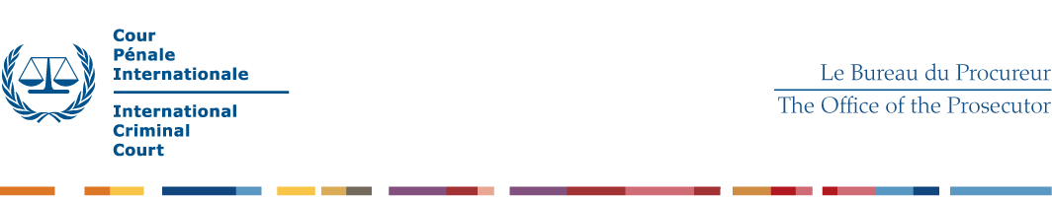
TERMS OF REFERENCE – Forensic Pathologist

- Operational Context

The Forensic Unit which is situated within the Forensic Science Section (FSS) of the Integrated Services Division assists, amongst other things, in the provision of specialised forensic and scientific support to Unified Teams.

- Tasks

The Office of the Prosecutor (OTP) of the International Criminal Court (ICC) is seeking to engage a Forensic Pathologist on a temporary basis. The Forensic Pathologist, under the supervision of the Head of Forensic Science Section, will provide support as follows:

- Provide forensic medical advice in accordance with OTP requirements and her/his field of professional expertise;
- Prepare forensic reports in English;
- Testify in court if required.

- Qualifications and Skills

- Advanced university degree in a relevant field. A first-level university degree in combination with two additional years of qualifying experience is accepted in lieu of the advanced university degree.
- Minimum of five years (seven years with a first level university degree) professional experience in forensic pathology.

Candidate should also possess the following skills and abilities:

- Ability to adapt standards to the reality of post-conflict environments;
- Ability and willingness to work flexible hours;
- Ability to work effectively and constructively;
- Excellent communication and drafting skills;
- Ability to work independently and under stressful conditions;
- Ability to keep strict standards of confidentiality and information security;
- Ability to work in a non-discriminatory manner, with respect for diversity;
- Relevant computer skills;
- Professional integrity;
- Knowledge of English is required.

